Times Roman Font Size 14 Bold Black

XYZ¹ , ABC^{2*}

1 Affiliation with City, PIN code, Country
2 Affilaition…., City, PIN, Countty
(Email: First Author , Email: *Corresponding Author)

Metal–organic frameworks (MOFs) are crystalline andporous materials composed of organic linkers coordinated to inorganic metal centers. Zeolitic Imidazolate Frameworks (ZIFs) are a subclass of MOFs that possess exceptional thermal and chemical stability along with easily tunable pore architecture. ZIFs undergo decomposition when subjected to higher temperatures. Multi-linker ZIF-62, a distinguished member of ZIF family, exhibits high thermal stability, and undergoes melting before thermal decomposition. On cooling, the ZIF-62 melt transforms to porous ZIF glass (a_{g}ZIF-62). For the gas separation applications, easily processible and durable a_{g}ZIF-62 holds an upper hand compared to its crystalline counterpart [2].

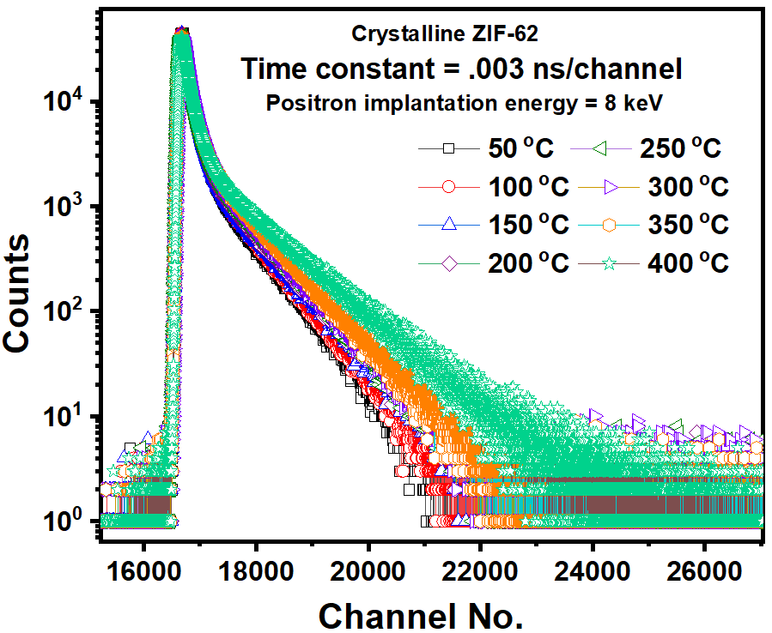

Figure 1. Caption Text

Table 1: Caption Text

Note ( Delete it from Abstract): Text 12 font size, 1.15 space, single column, A4 size paper , margin 1 inch (2.5 cm) from all sides Table and Figures are optional and Keep caption Outside the figure.
For Keynote/ IT: Author could be One (first & Corresponding Author same), Contributed abstract, as usual one or more authors. Internal/ Divisional Permission is responsibility of First/ Corresponding Author, NPMMI-2026 will not be responsible.

Acknowledgements: 1-2 lines only

References:
- Y. Wanget, XYZ, ABC, Angew. Chem. Int. Ed., 59 (2020) 433
- N.Vahidetal., J. Chem. Phys., 20 (2020) 204501

